SFGH ED Bedside Ultrasound Ordering

- Place an order for a ED B/S Ultrasound
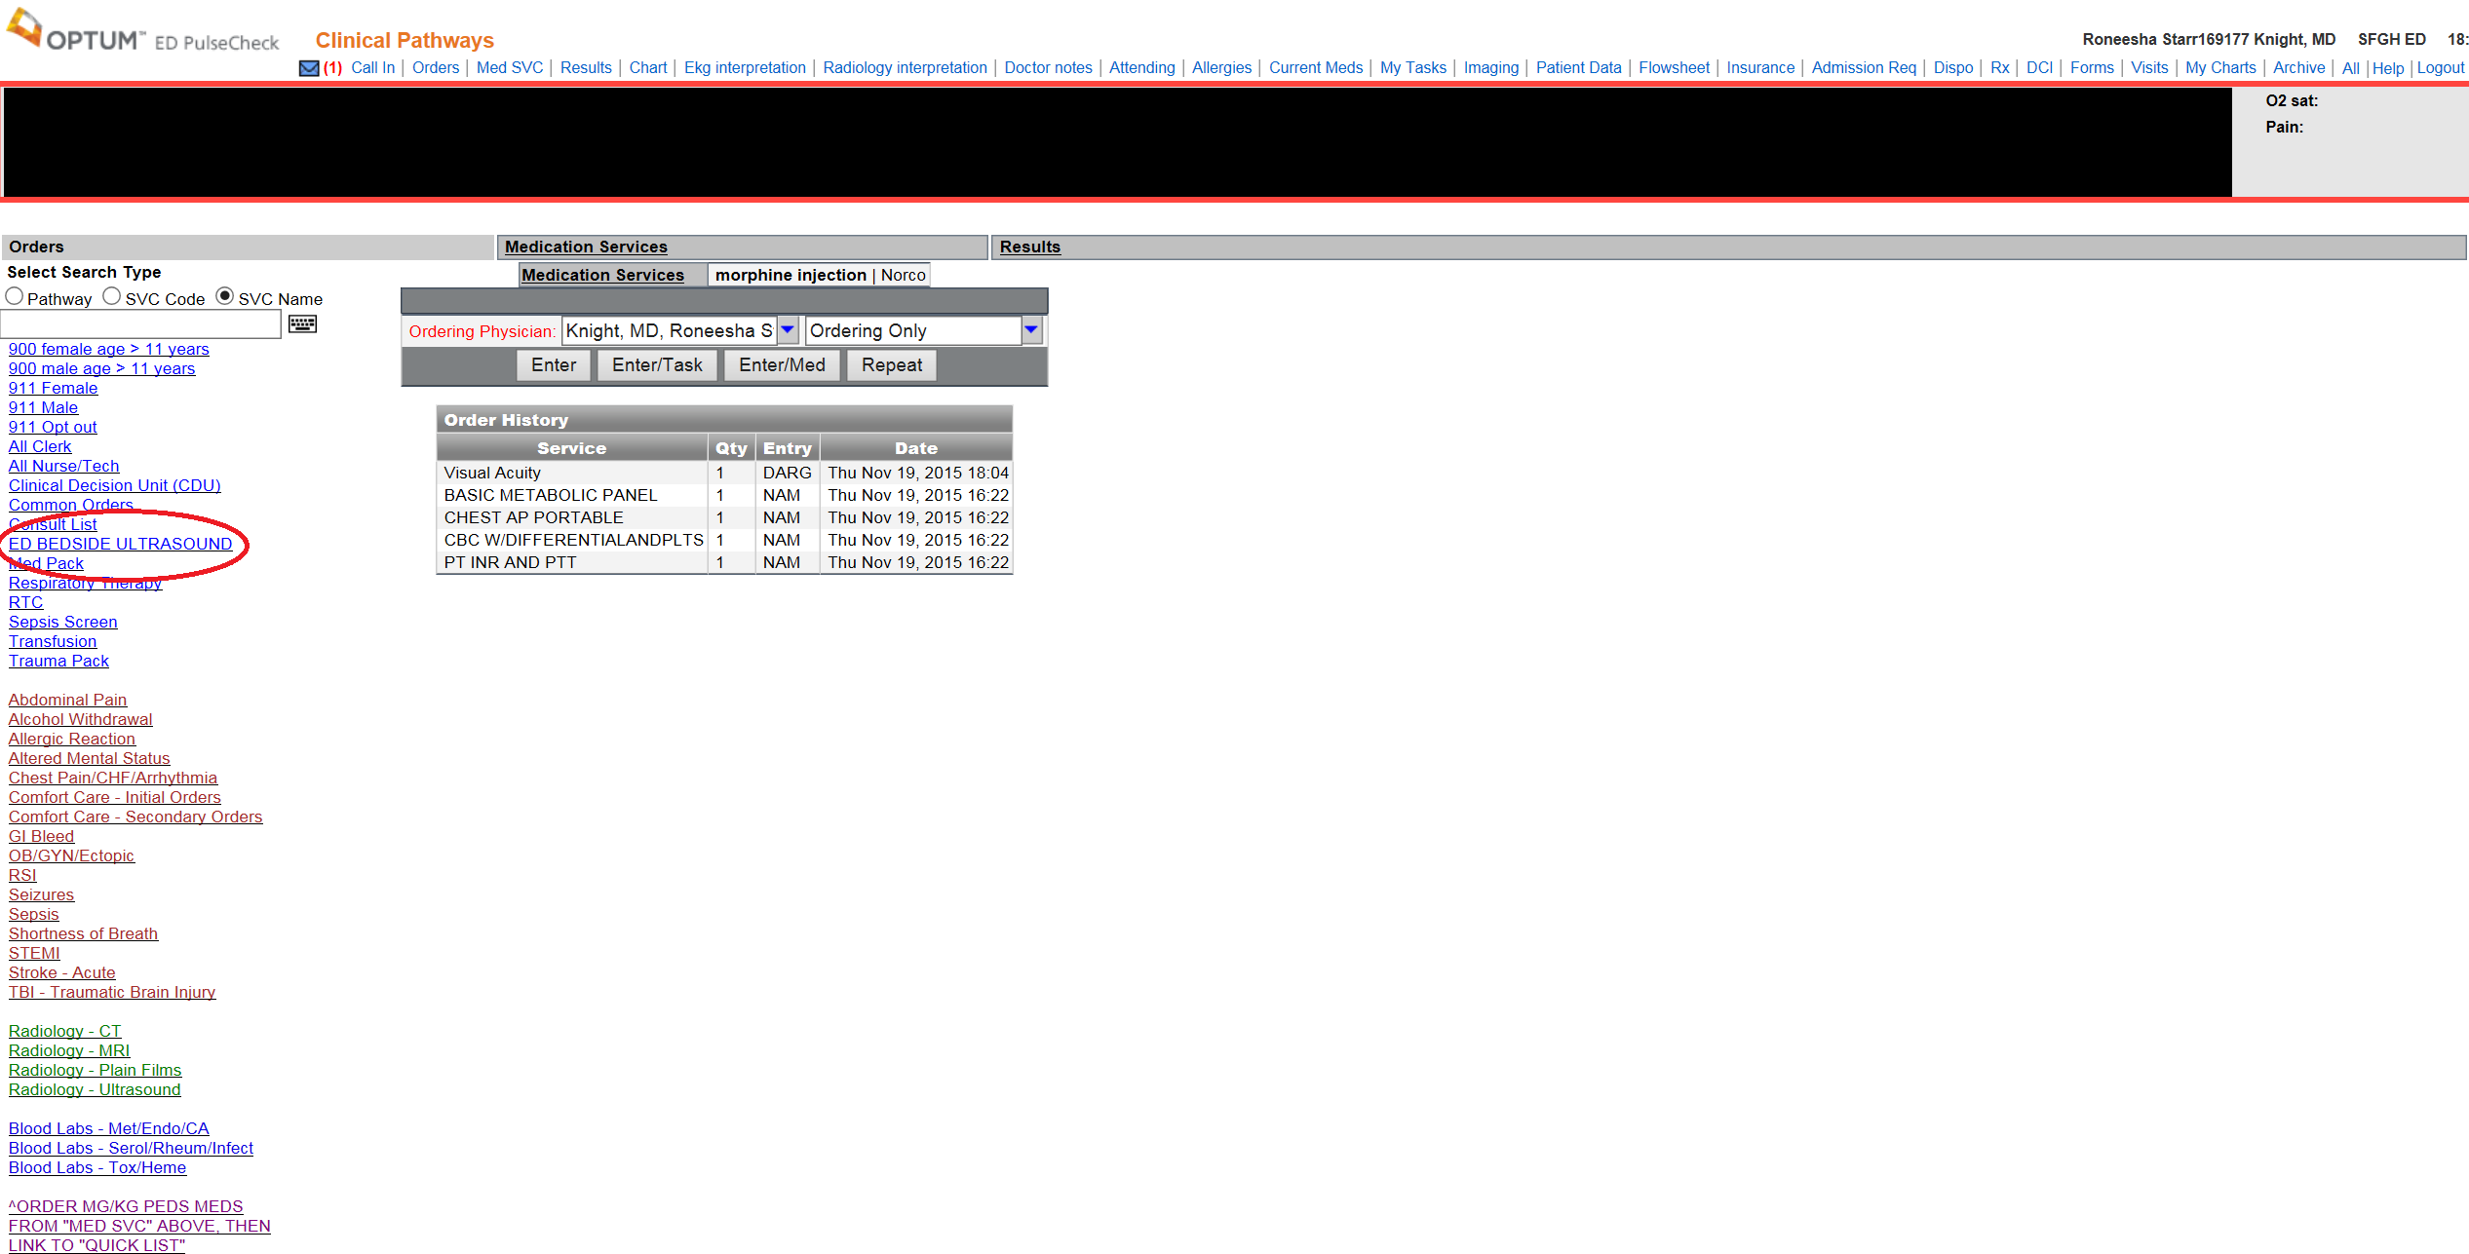
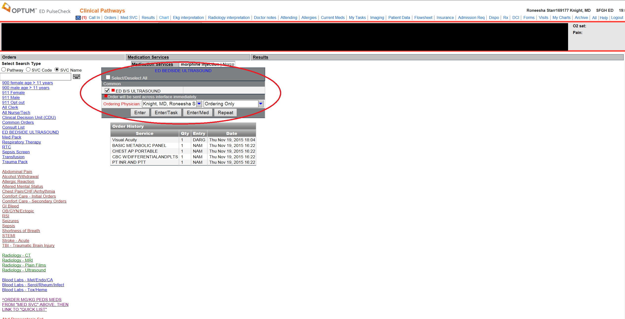

You can confirm your order by looking in the Order Section of the Chart:
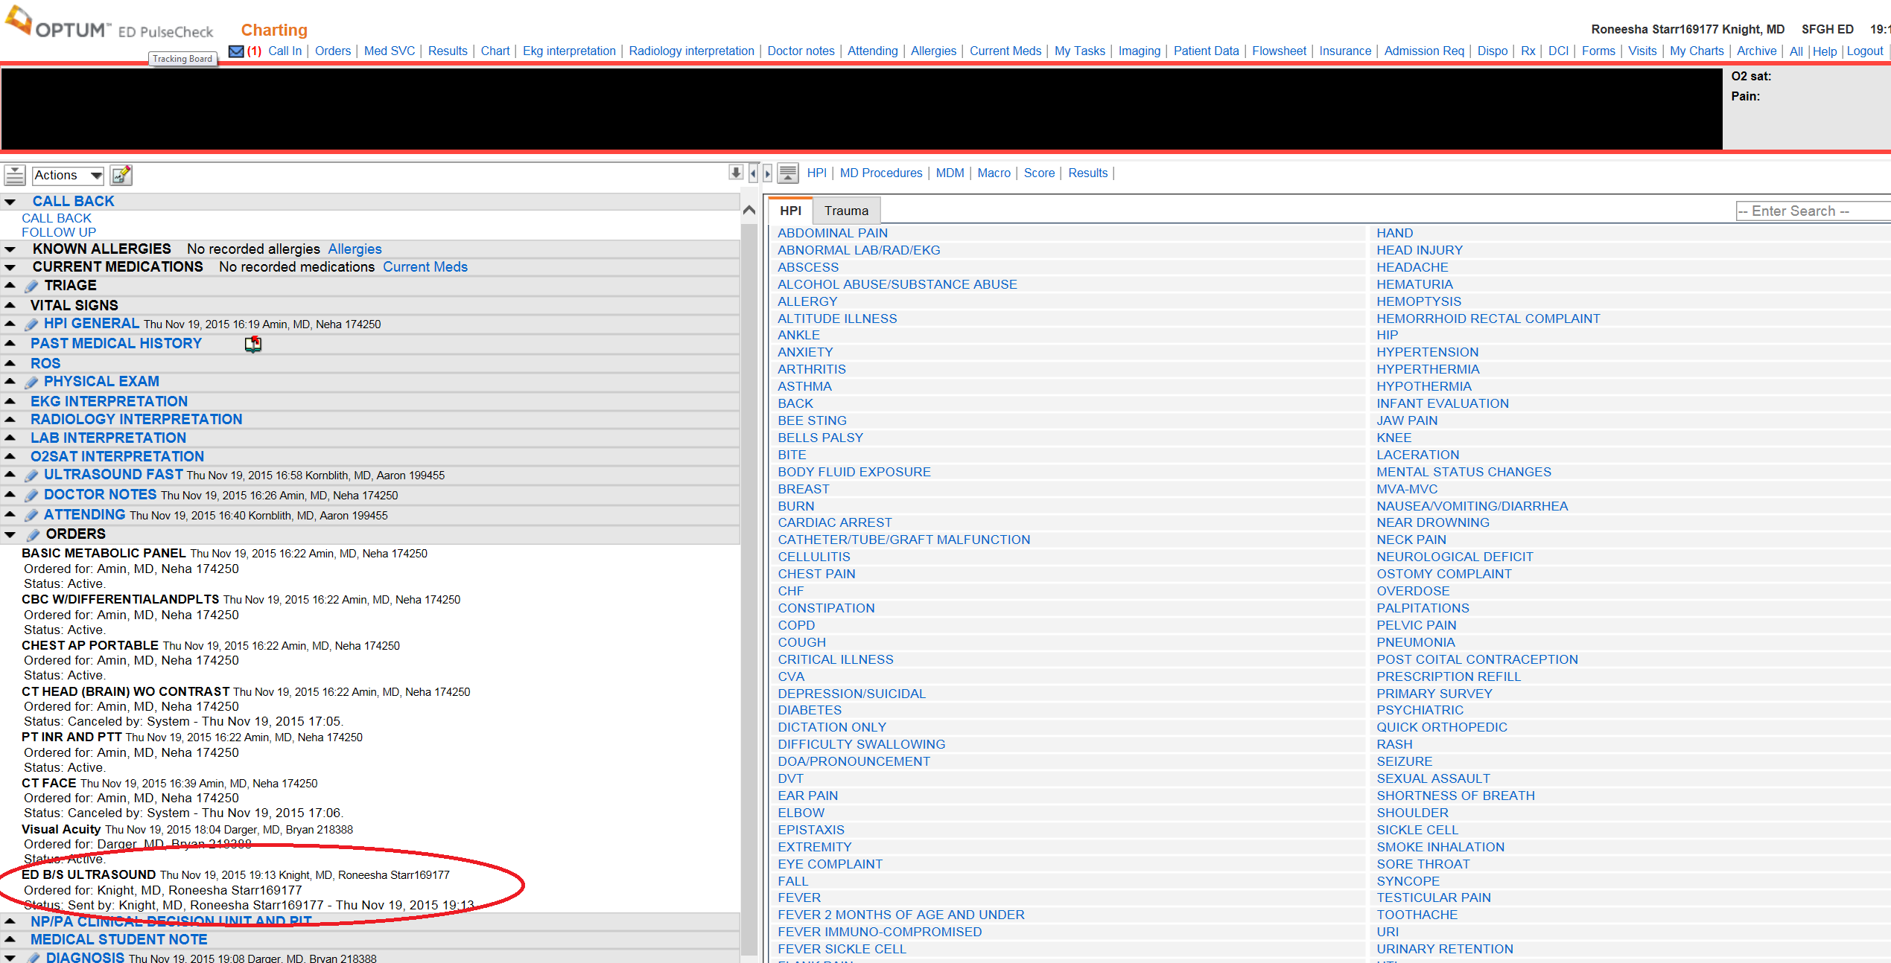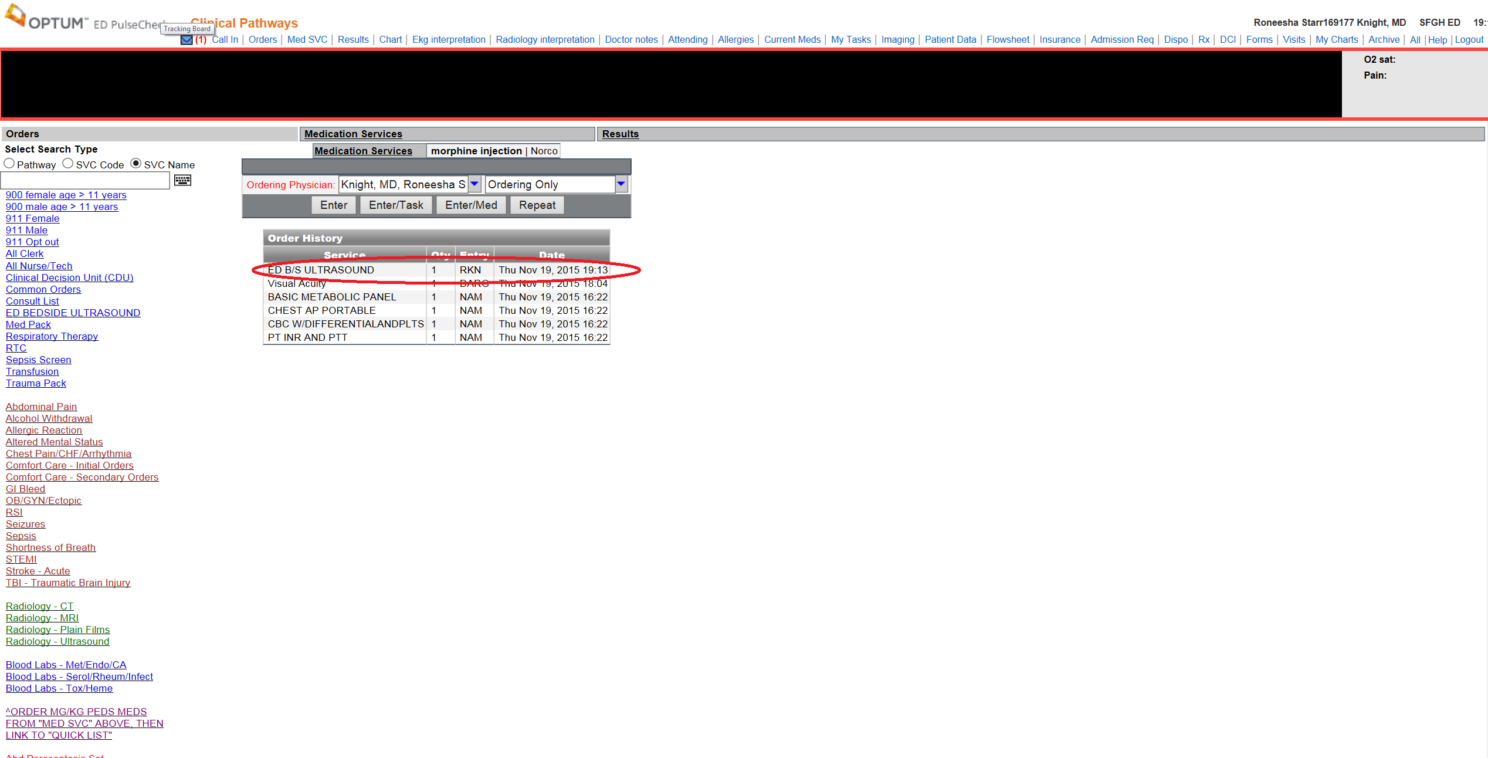

- Select an Ultrasound Machine of your choice and Press the “Patient” Button and Select “Worklist”:
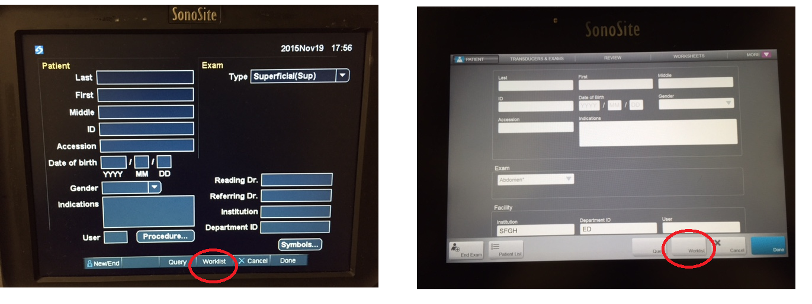

- Select the patient’s info and press done… Happy Scanning!!!!
- If you do not see your patient’s information, select the “Update” Button
