SFGH Scanning Protocols
(Adapted from the ACEP Ultrasound Imaging Criteria Compendium)

Aorta

Indications
- Primary
  - The rapid evaluation of the abdominal aorta from the diaphragmatic hiatus to the aortic bifurcation for evidence of aneurysm.
- Extended/Advanced
  - Intraperitoneal free fluid evaluation in the event that AAA is identified
  - Abdominal aortic dissection
  - Thoracic aortic dissection
  - Iliac, splenic, and other abdominal artery aneurysms

- Contraindications
  - There are no absolute contraindications to EUS of the abdominal aorta. There may be relative contraindications based on the patient’s clinical situation.

- Limitations
  - EUS of the aorta is a single component of the overall and ongoing resuscitation. Since it is a focused examination, EUS does not identify all abnormalities or diseases of the aorta. EUS, like other tests, does not replace clinical judgment and should be interpreted in the context of the entire clinical picture. If the findings of the EUS are equivocal additional diagnostic testing may be indicated.
  - Examination of the aorta may be technically limited by
    - Obese habitus
    - Bowel gas
    - Abdominal tenderness
    - Abdominal dressings

- Technique
  - Curvilinear or Phased Array Probe
  - Transverse view of the Aorta from the Xiphoid Process to the Bifurcation.
    - Measurements from the outside wall-to- outside wall should be made of the proximal, mid, and distal aorta
    - Anterior-Posterior Diameter should be measured
    - Lateral-Lateral Diameter may also be measured when possible.
  - Longitudinal views of the Aorta should be obtained as well.
  - If a AAA is identified a FAST Exam should be performed to evaluate for peritoneal fluid.
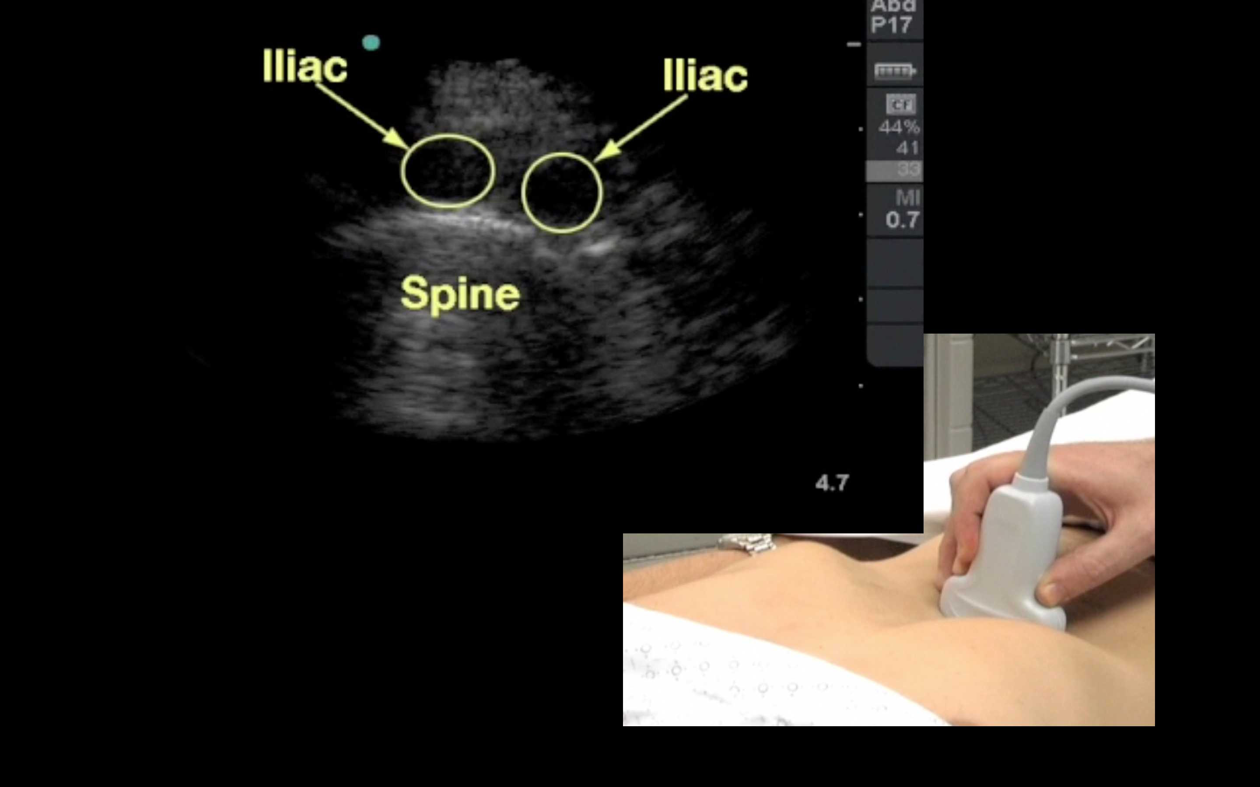

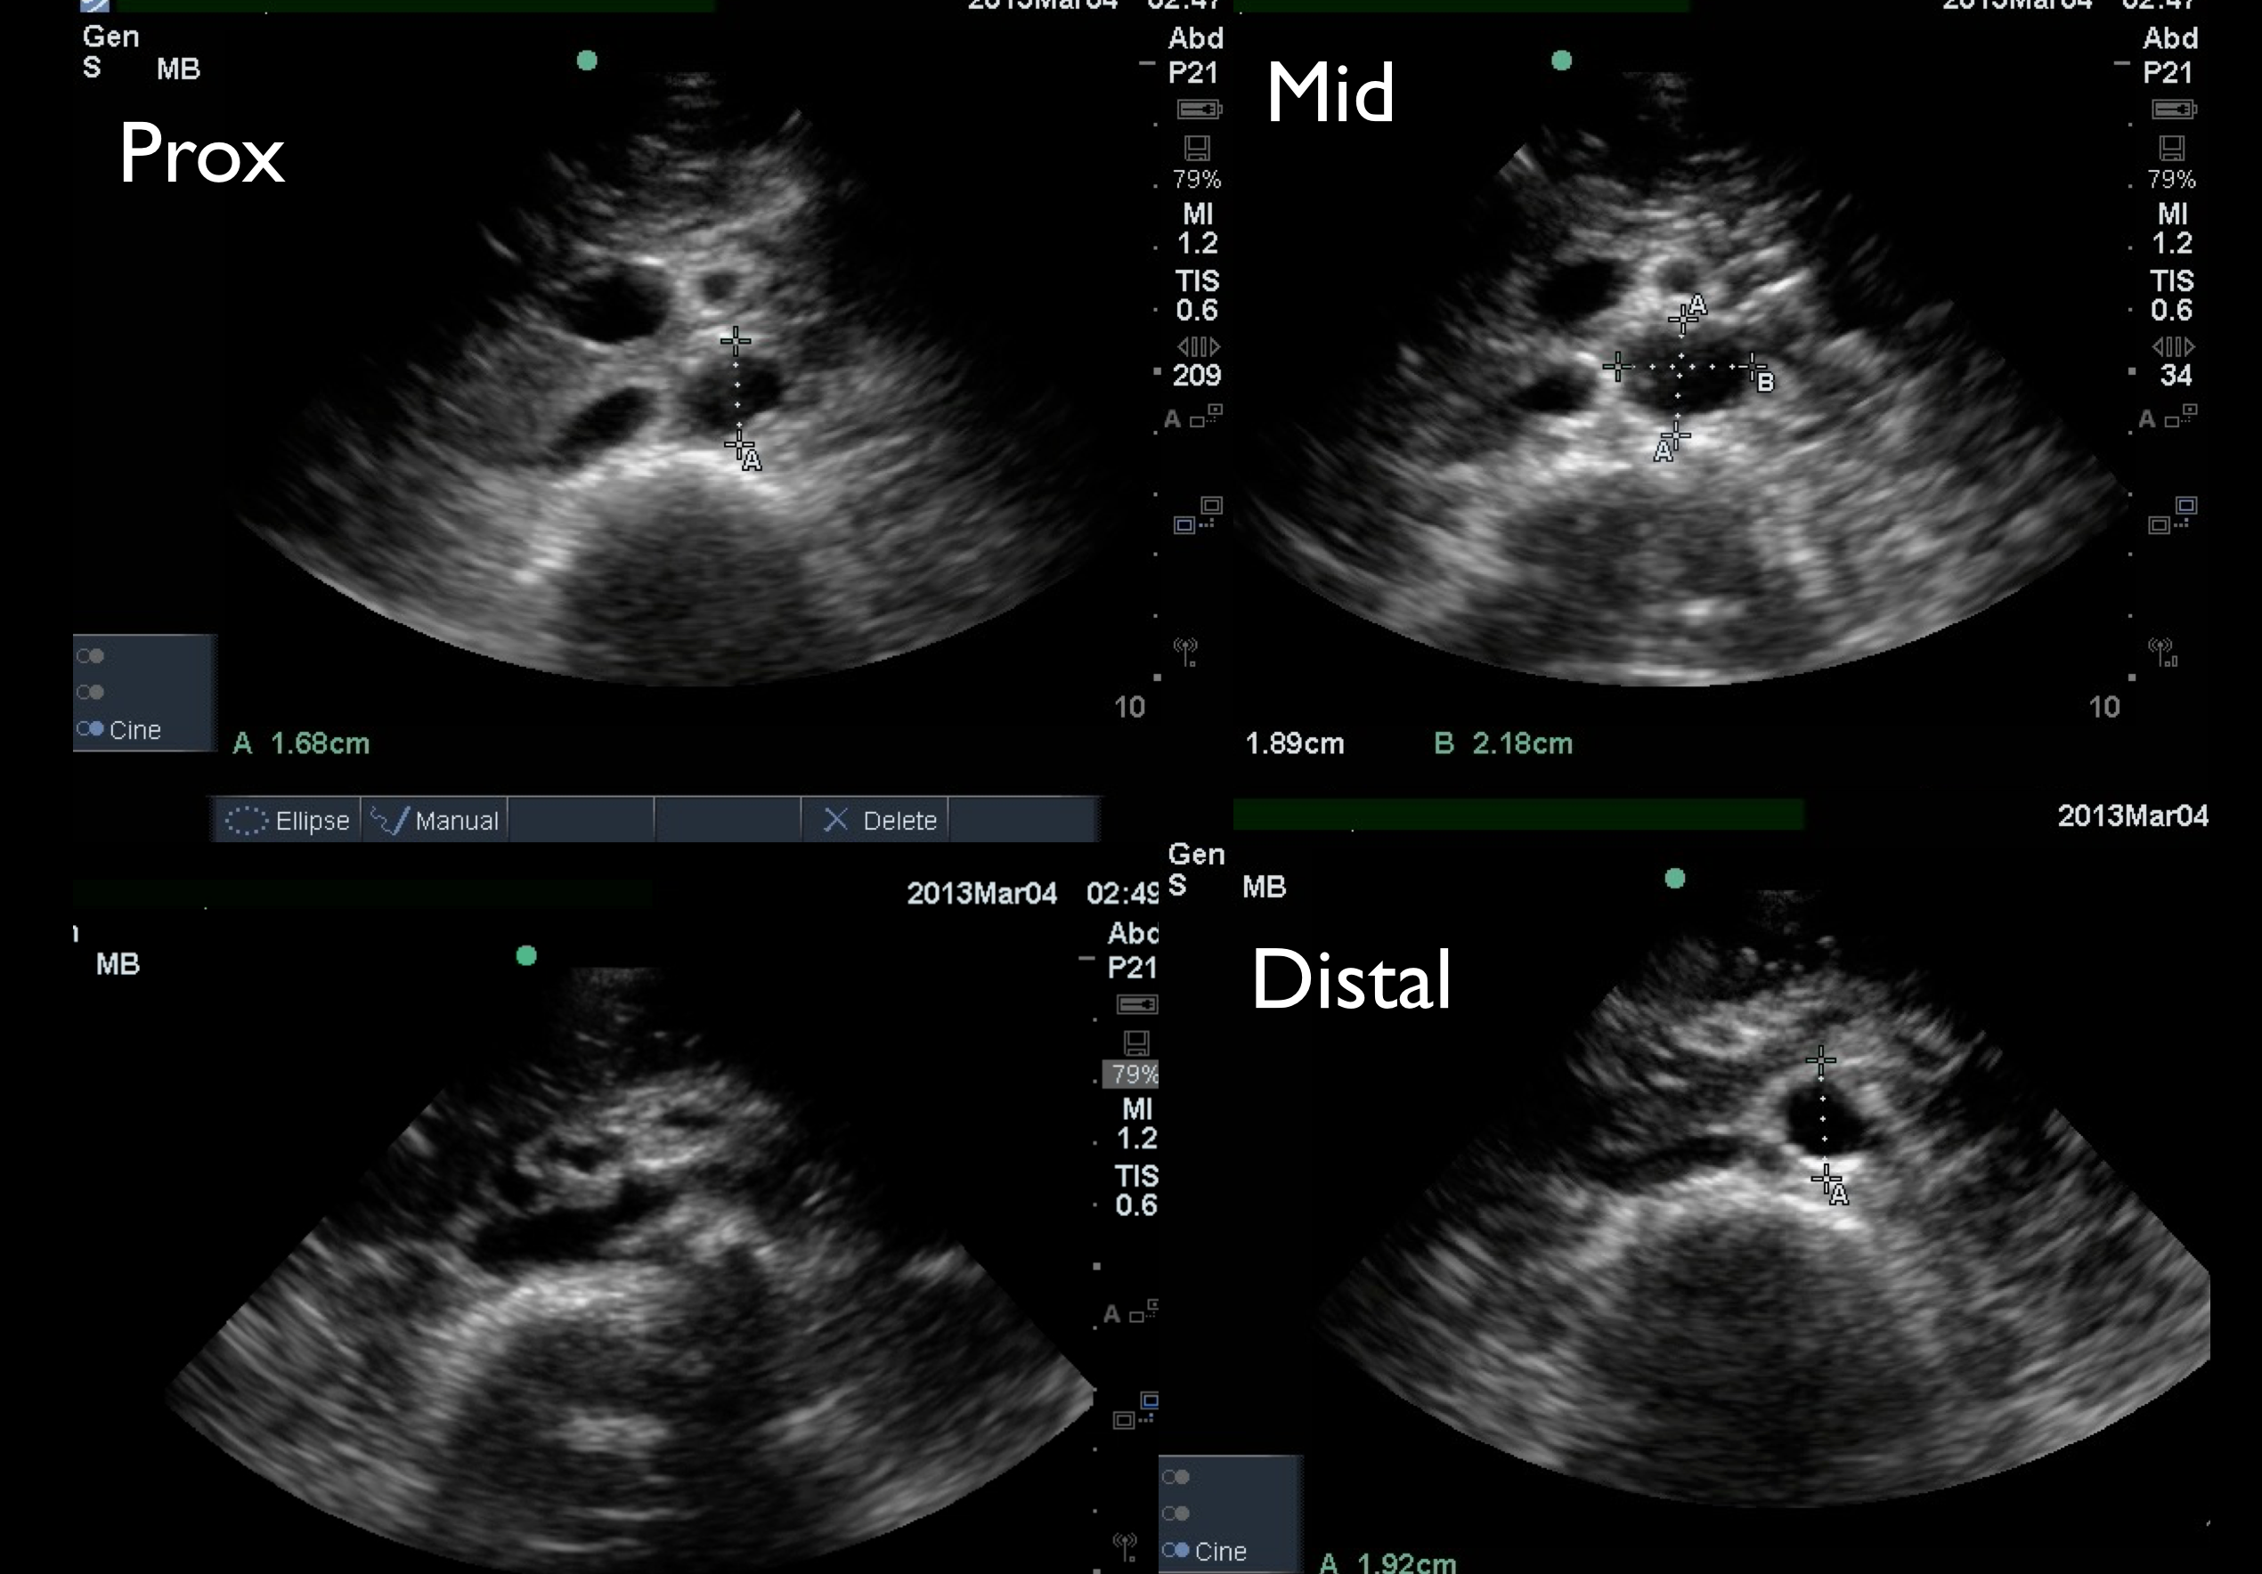
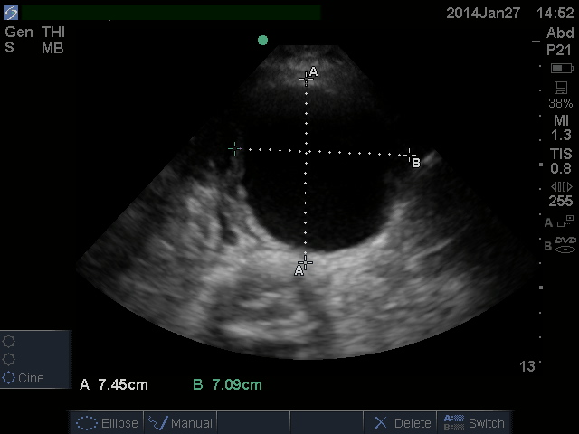
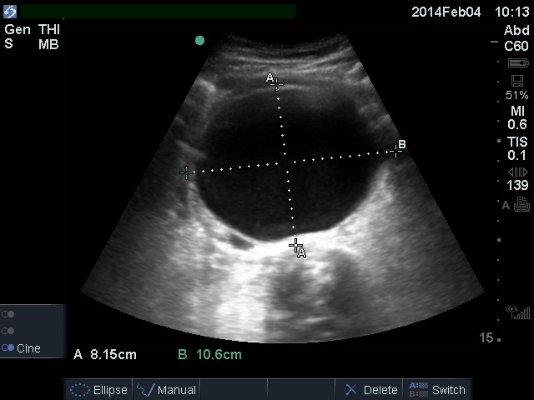
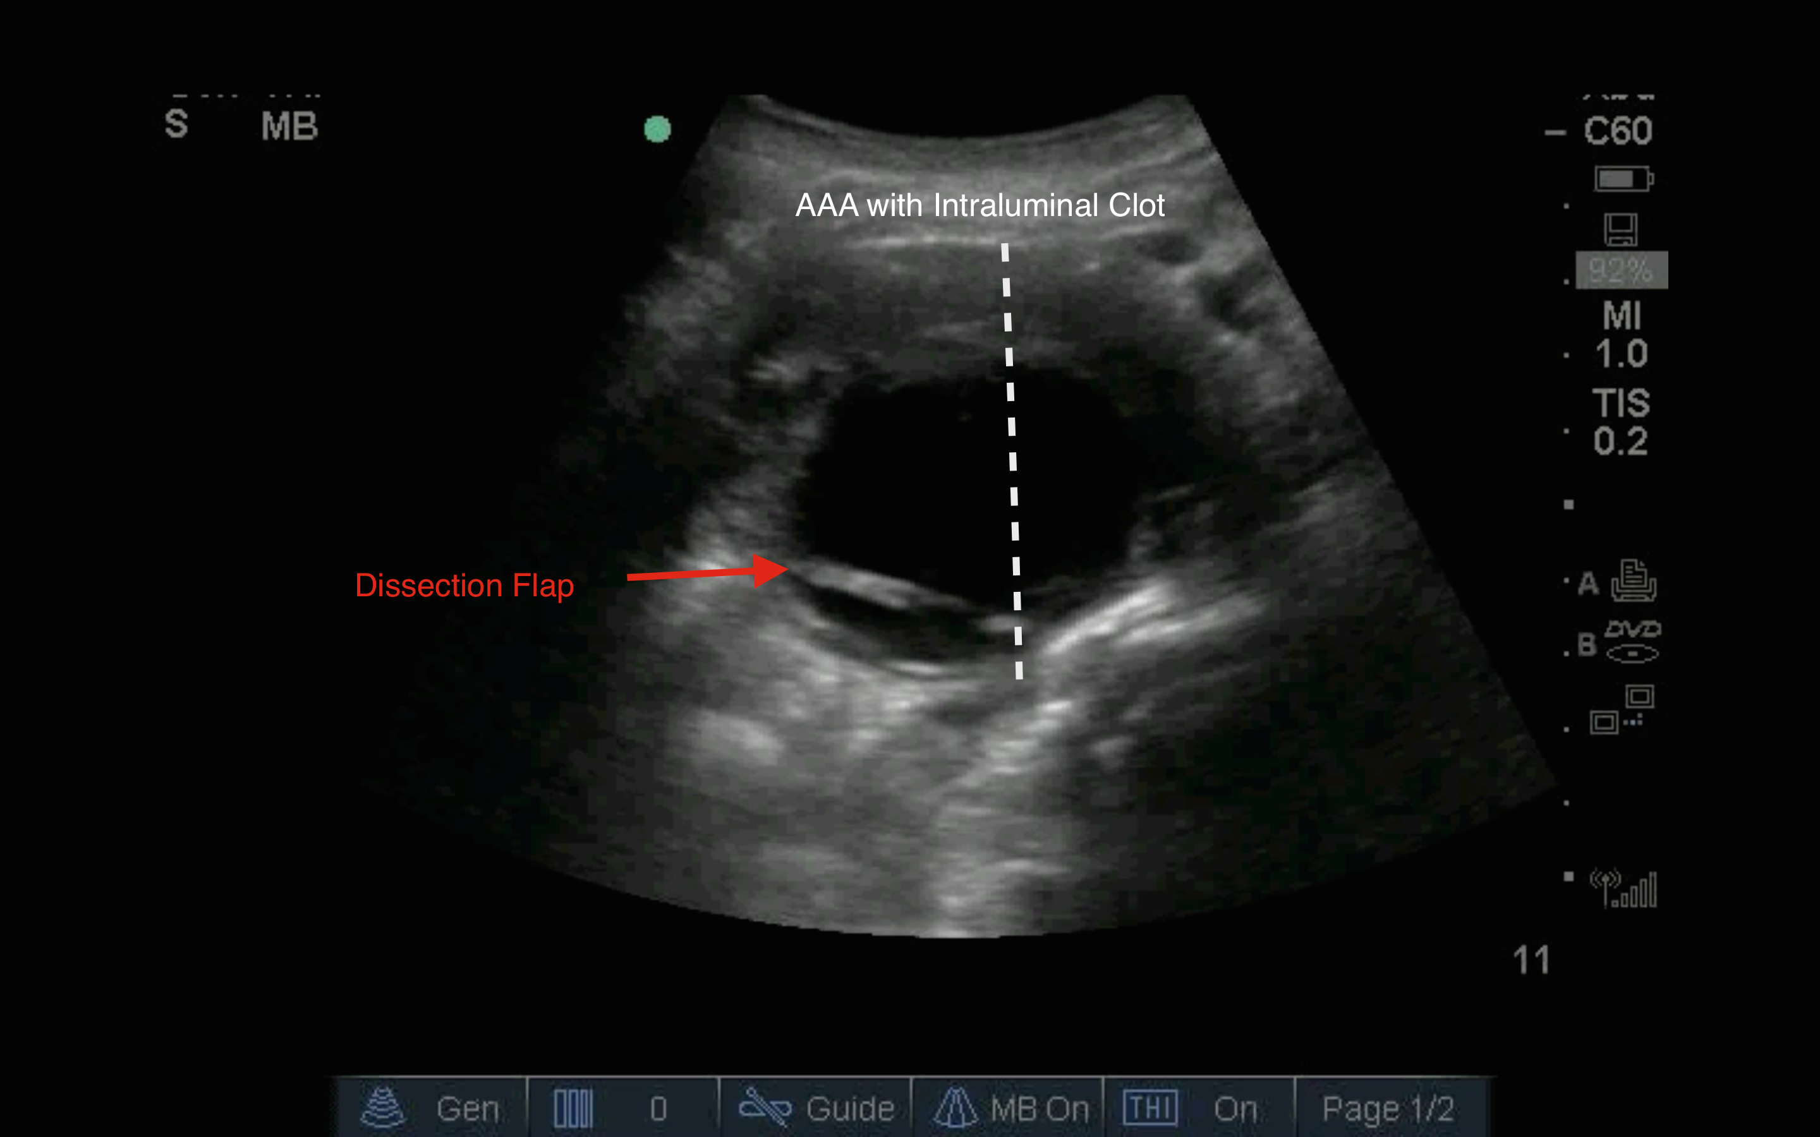

LONG AXIS AAA

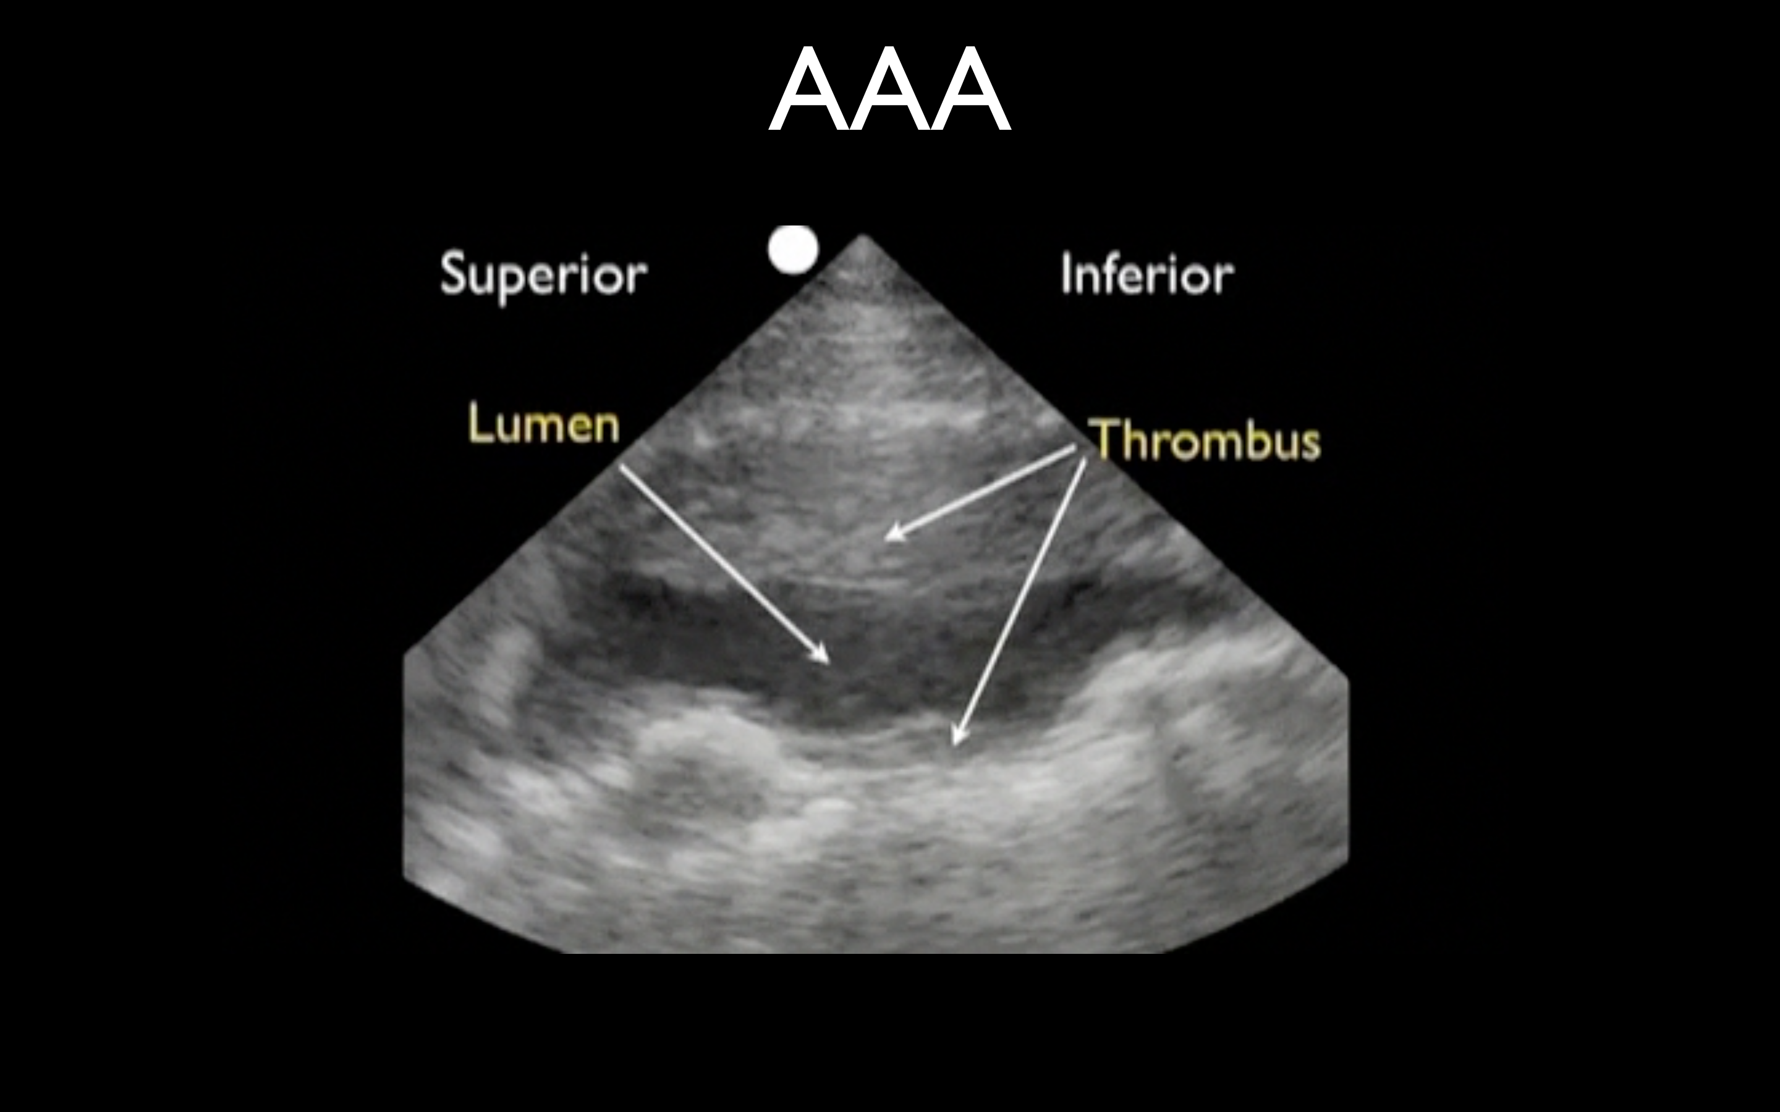
- Pitfalls
  - While most aneurysms are fusiform, extending over several centimeters of aorta, saccular aneurysms are confined to a short focal section of the aorta, making them easily overlooked. This may be avoided by methodical, systematic real-time scanning through all tissue planes in both transverse and longitudinal sections.
  - When bowel gas or other technical factors prevent a complete systematic real-time scan in orthogonal planes, these limitations should be identified and documented. Such limitations may mandate further evaluation by alternative methods, as clinically indicated.
  - A small aneurysm does not preclude rupture. A patient with symptoms consistent with acute AAA and an aortic diameter greater than 3.0 cm should undergo further diagnostic evaluation.
  - The absence of free intraperitoneal fluid does not rule out acute AAA rupture.
  - The presence of retroperitoneal hemorrhage cannot be reliably identified by EUS.
  - The presence of free intraperitoneal fluid with an AAA, does not necessarily mean that the aneurysm is the source of the fluid.
  - Oblique or angled cuts exaggerate the true aortic diameter. Scanning planes should be obtained that are either exactly aligned with, or at exact right angles to, the main axis of the vessel.
  - Off-plane longitudinal images and transverse images not obtained at the level of maximal dilatation will underestimate the true diameter of the vessel.
  - With a tortuous or ectatic aorta “longitudinal” and “transverse” views should be obtained with respect to the axis of the vessel in order to avoid artifactual exaggeration of the aortic diameter.
  - Large para-aortic nodes may be confused with the aorta and/or AAA. They usually occur anterior to the aorta, but may be posterior, displacing the aorta away from the vertebral body. They can be distinguished by an irregular nodular shape, identifiable in real-time. If color flow Doppler is utilized, nodes will not demonstrate high-velocity luminal flow.
  - Longstanding thrombus within an AAA may become calcified and mistaken for bowel outside the aorta, thereby obscuring the aortic walls and preventing recognition of the aneurysm. Gain should be adjusted so that blood within the lumen of the vessel appears anechoic (ie, black).

