SFGH Scanning Protocols
(Adapted from the ACEP Ultrasound Imaging Criteria Compendium)

Renal

Indications
- Primary
  - The rapid evaluation of the urinary tract for sonographic evidence of obstructive uropathy and/or urinary retention in a patient with clinical findings suggestive of these diseases.
- Extended
  - Causes of obstructive uropathy
  - Causes of acute hematuria
  - Causes of acute renal failure
  - Infections and abscesses of the kidneys
  - Renal cysts and masses
  - Gross bladder and prostate abnormalities
  - Renal trauma

Contraindications
  - There are no absolute contraindications to emergency ultrasound (EUS) of the kidneys and bladder. There may be relative contraindications based on the specific features of the patient’s clinical situation.

Limitations
- EUS of the kidney and urinary tract is a single component of the overall and ongoing evaluation. Since it is a focused examination EUS does not identify all abnormalities or diseases of the urinary tract. EUS, like other tests, does not replace clinical judgment and should be interpreted in the context of the entire clinical picture. If the findings of the EUS are equivocal, additional diagnostic testing may be indicated.
- Examination of the kidneys and collecting system may be technically limited by:
  - Patient habitus including obesity, paucity of subcutaneous fat, narrow intercostal spaces
  - Bowel gas
  - Abdominal or rib tenderness
  - An empty bladder

Technique
  - A Curvilinear Probe is optimal. A phased array probe or linear probe may provide better resolution in children or smaller adults.
  - An attempt should be made to image both kidneys and the bladder in patients with suspected renal tract pathology undergoing EUS.
  - Images of both kidneys should be obtained in the longitudinal and transverse planes for purposes of comparison and to exclude absence of either kidney. The bladder should be imaged to assess for volume, evidence of distal ureteral obstruction and for calculi. As with other EUS exams, the organs of interest are scanned in real-time through all tissue planes in at least two orthogonal directions.

  - Kidney Evaluation
    - The right kidney may be visualized with an anterior subcostal approach using the liver as a sonographic window. Having the patient in the left lateral decubitus position or prone may facilitate imaging. Asking the patient to take and hold a deep breath may serve to extend the liver window so that it includes the inferior pole of the kidney. Despite these techniques, parts or the entire kidney may not bee seen in this view due to interposed loops of bowel, in which case the kidney should be imaged using an intercostal approach in the right flank between the anterior axillary line and mid axillary line. For this approach, the patient can be placed in the decubitus position with a bolster under the lower side with the arm of the upper side fully abducted, thus spreading the intercostal spaces. Separate views of the superior and inferior poles are often required to adequately image the entire kidney in its longitudinal plane. To obtain transverse images, the transducer is rotated 90 degrees counter-clockwise from the longitudinal plane. Once n the transverse plane, the transducer can be moved superiorly and medially, or inferiorly and laterally to locate the renal hilum. Images cephalad to the hilum represent the superior pole and those caudad represent the inferior pole. The left kidney lacks the hepatic window, necessitating an intercostal approach similar to the one described for the right flank.

  - Bladder View
    - The bladder is imaged from top to bottom and from side to side, in transverse and sagittal planes, respectively. While a full bladder facilitates bladder scanning, distension may be a cause of artifactual hydronephrosis and is therefore to be avoided in scanning the kidneys. Ideally, the bladder is scanned prior to voiding (and again post-void, if outlet obstruction is a consideration), and kidney scanning performed after voiding. Such ideal conditions are rarely met with the exigencies of EUS and emergency care.
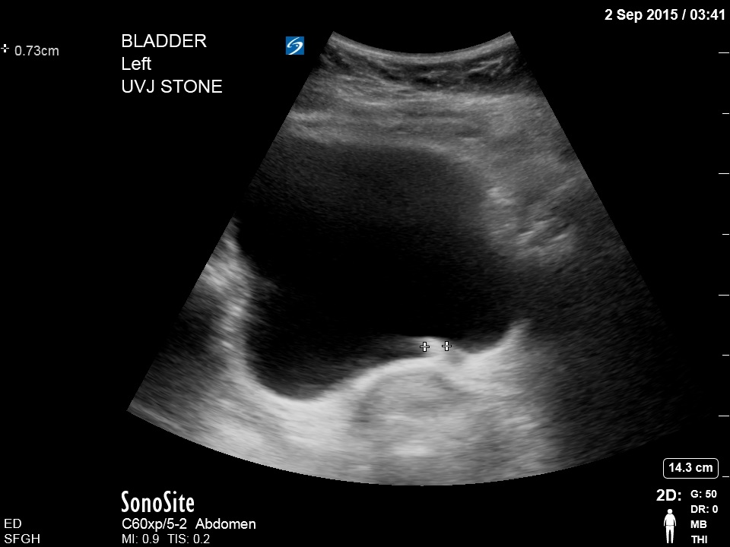

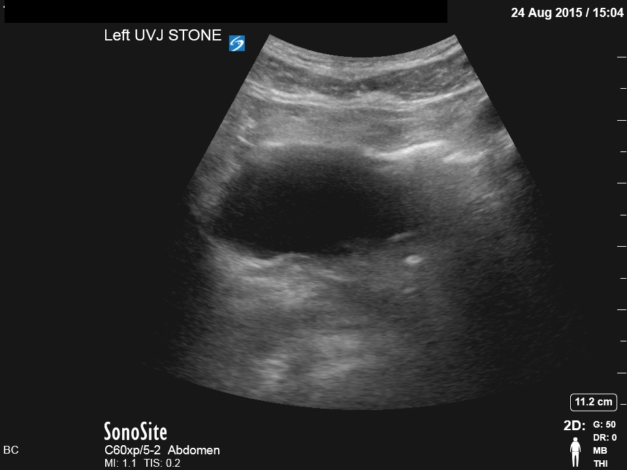

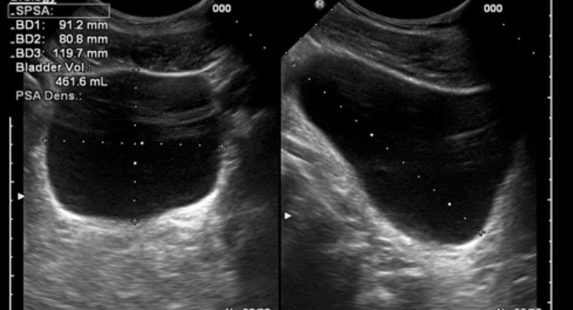

Keys to Renal Ultrasound
- The kidneys should be studied for abnormalities of the renal sinus and parenchyma. Under normal circumstances, the renal collecting system contains no urine, so that the renal sinus is a homogeneously hyperechoic structure. A distended bladder can cause mild hydronephrosis in normal healthy adults. Several classifications of hydronephrosis have been suggested. One that is easily applied and widely utilized is Mild or Grade I (any hydronephrosis up to Grade II), Moderate or Grade II (the calices are confluent resulting in a “bear’s paw” appearance), or Severe or Grade III (the hydronephrosis is sufficiently extensive to cause effacement of the renal parenchyma). Other abnormalities identified including cysts, masses and bladder abnormalities may require additional diagnostic evaluation. Measurements may be made of the dimensions of abnormal findings and the length and width of the kidneys. Such measurements are rarely relevant in the EUS examination.

Mild Hydronephrosis
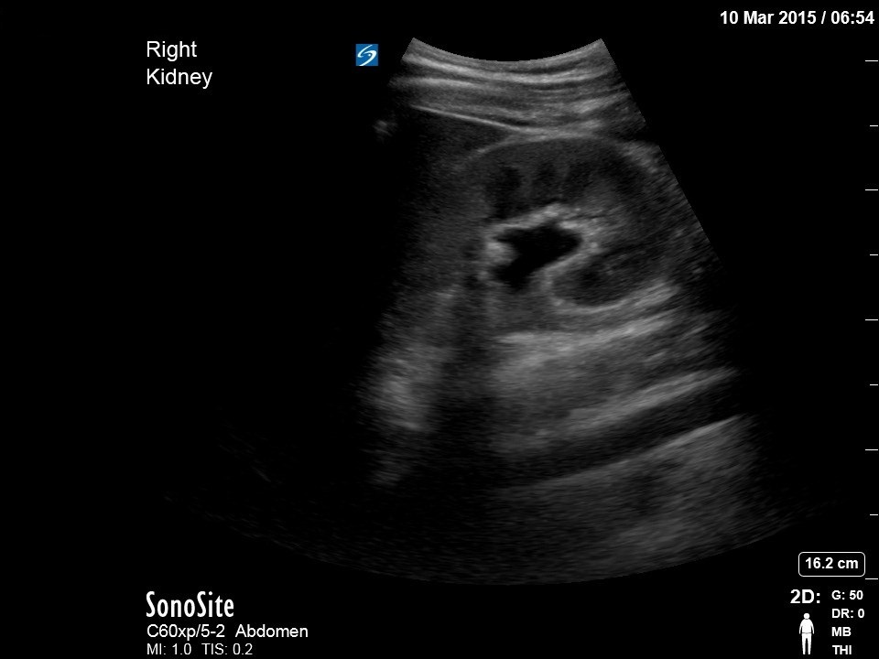

Moderate Hydronephrosis
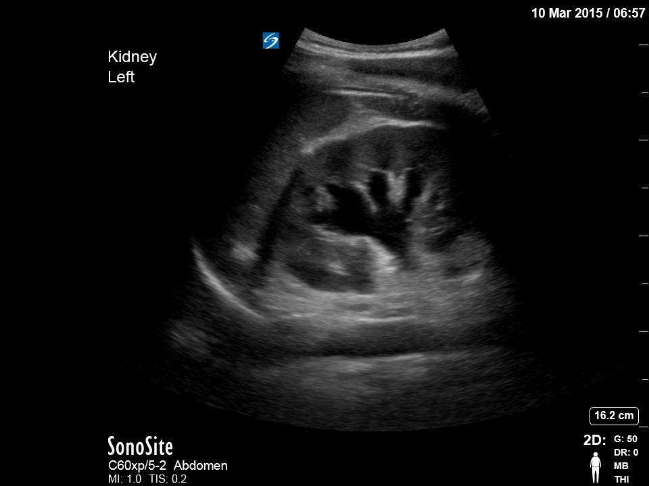

Moderate Hydronephrosis with no Color Flow noted
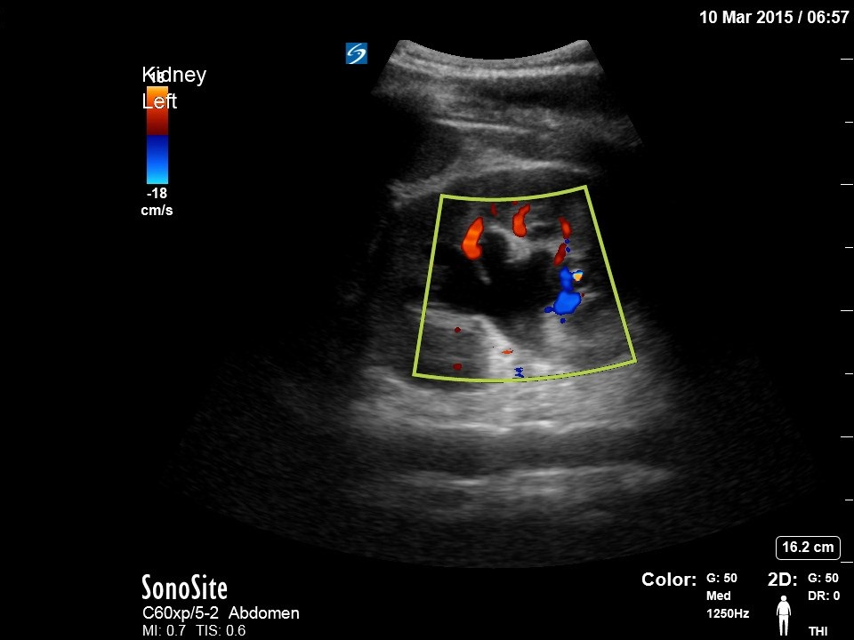

Moderate-Severe Hydronephrosis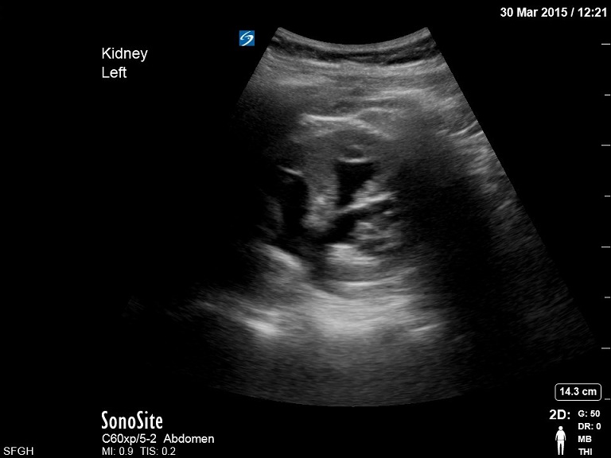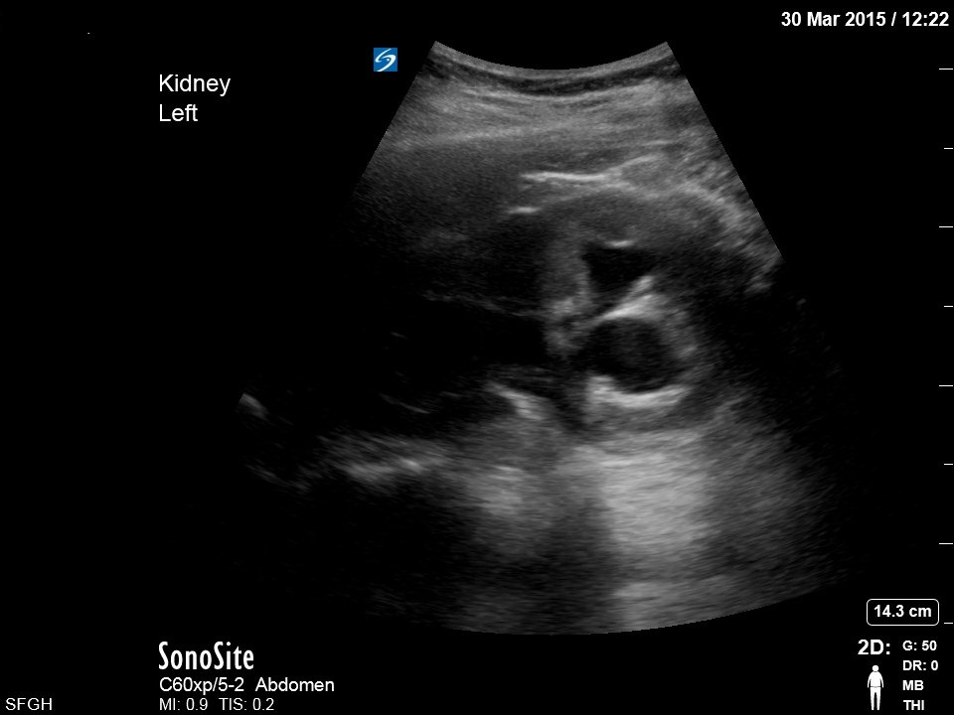

Pitfalls

- When bowel gas or other technical factors prevent a complete real-time scan through all tissue planes, the limitations of the examination should be identified and documented. As is customary in emergency practice, such limitations may mandate further evaluation by alternative methods, as clinically indicated.
- Hydronephrosis may be mimicked by several normal and abnormal conditions including dilated renal vasculature, renal sinus cysts, and bladder distension. Medullary pyramids may mimic hydronephrosis, especially in young patients.
- Presence of obstruction may be masked by dehydration.
- Absence of hydronephrosis does not rule out a ureteral stone. Many ureteral stones, especially small ones, do not cause hydronephrosis.
- Patients with an acutely symptomatic abdominal aortic aneurysm may present with symptoms suggestive of acute renal colic.
- Both kidneys should be imaged in order to identify the presence of either unilateral kidney or bilateral disease processes.
- The bladder should be imaged as part of EUS of the kidney and urinary tract. Many indications of this EUS exam are caused by conditions identifiable in the bladder.
- Variations of renal anatomy are not uncommon and may be mistaken for pathologic conditions. These include reduplicated collection systems, unilateral, bipartite, ectopic and horse-shoe kidney.
- Renal stones smaller than 3 mm are usually not identified by current sonographic equipment. Renal stones of all sizes may be missed and are usually identified by the shadowing they cause as their echogenicity is similar to that of surrounding renal sinus fat.

